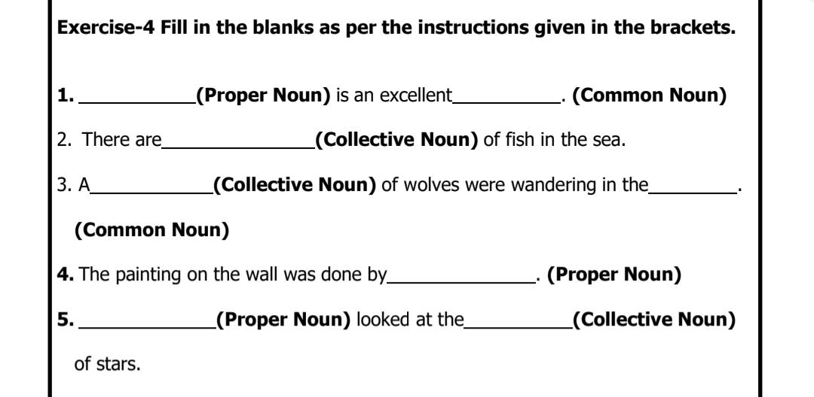
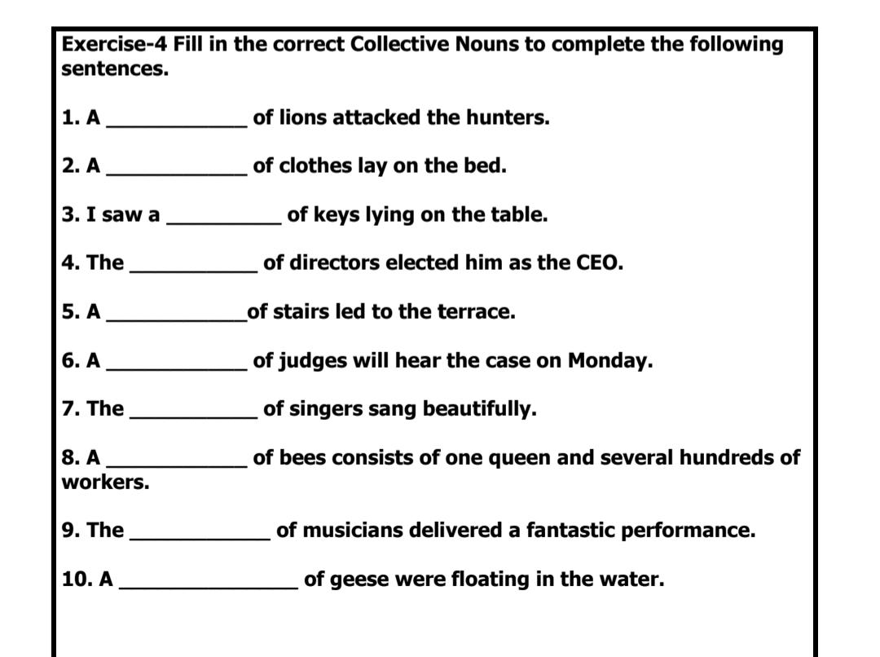

Write the quality that these people have.
1. A sincere person
2. An honest man
3. A happy child
4. An angry boss
5. A brave soldier
6. A proud lady
7. A kind man
8. A beautiful princess

- Pride
- Stack, Pile
- Bunch
- Board
- Flight
- Jury
- Choir
- Gaggle

- A sincere person- SINCERITY
- An honest man- HONESTY
- A happy child- HAPPINESS
- An angry boss- ANGER
- A brave soldier- BRAVERY
- A proud lady-PRIDE
- A kind man-KINDNESS
- A beautiful princess-BEAUTY

